CURRICULUM VITAE

Name: Ayman Farouk Abdel-Kawi Abdel-Galil

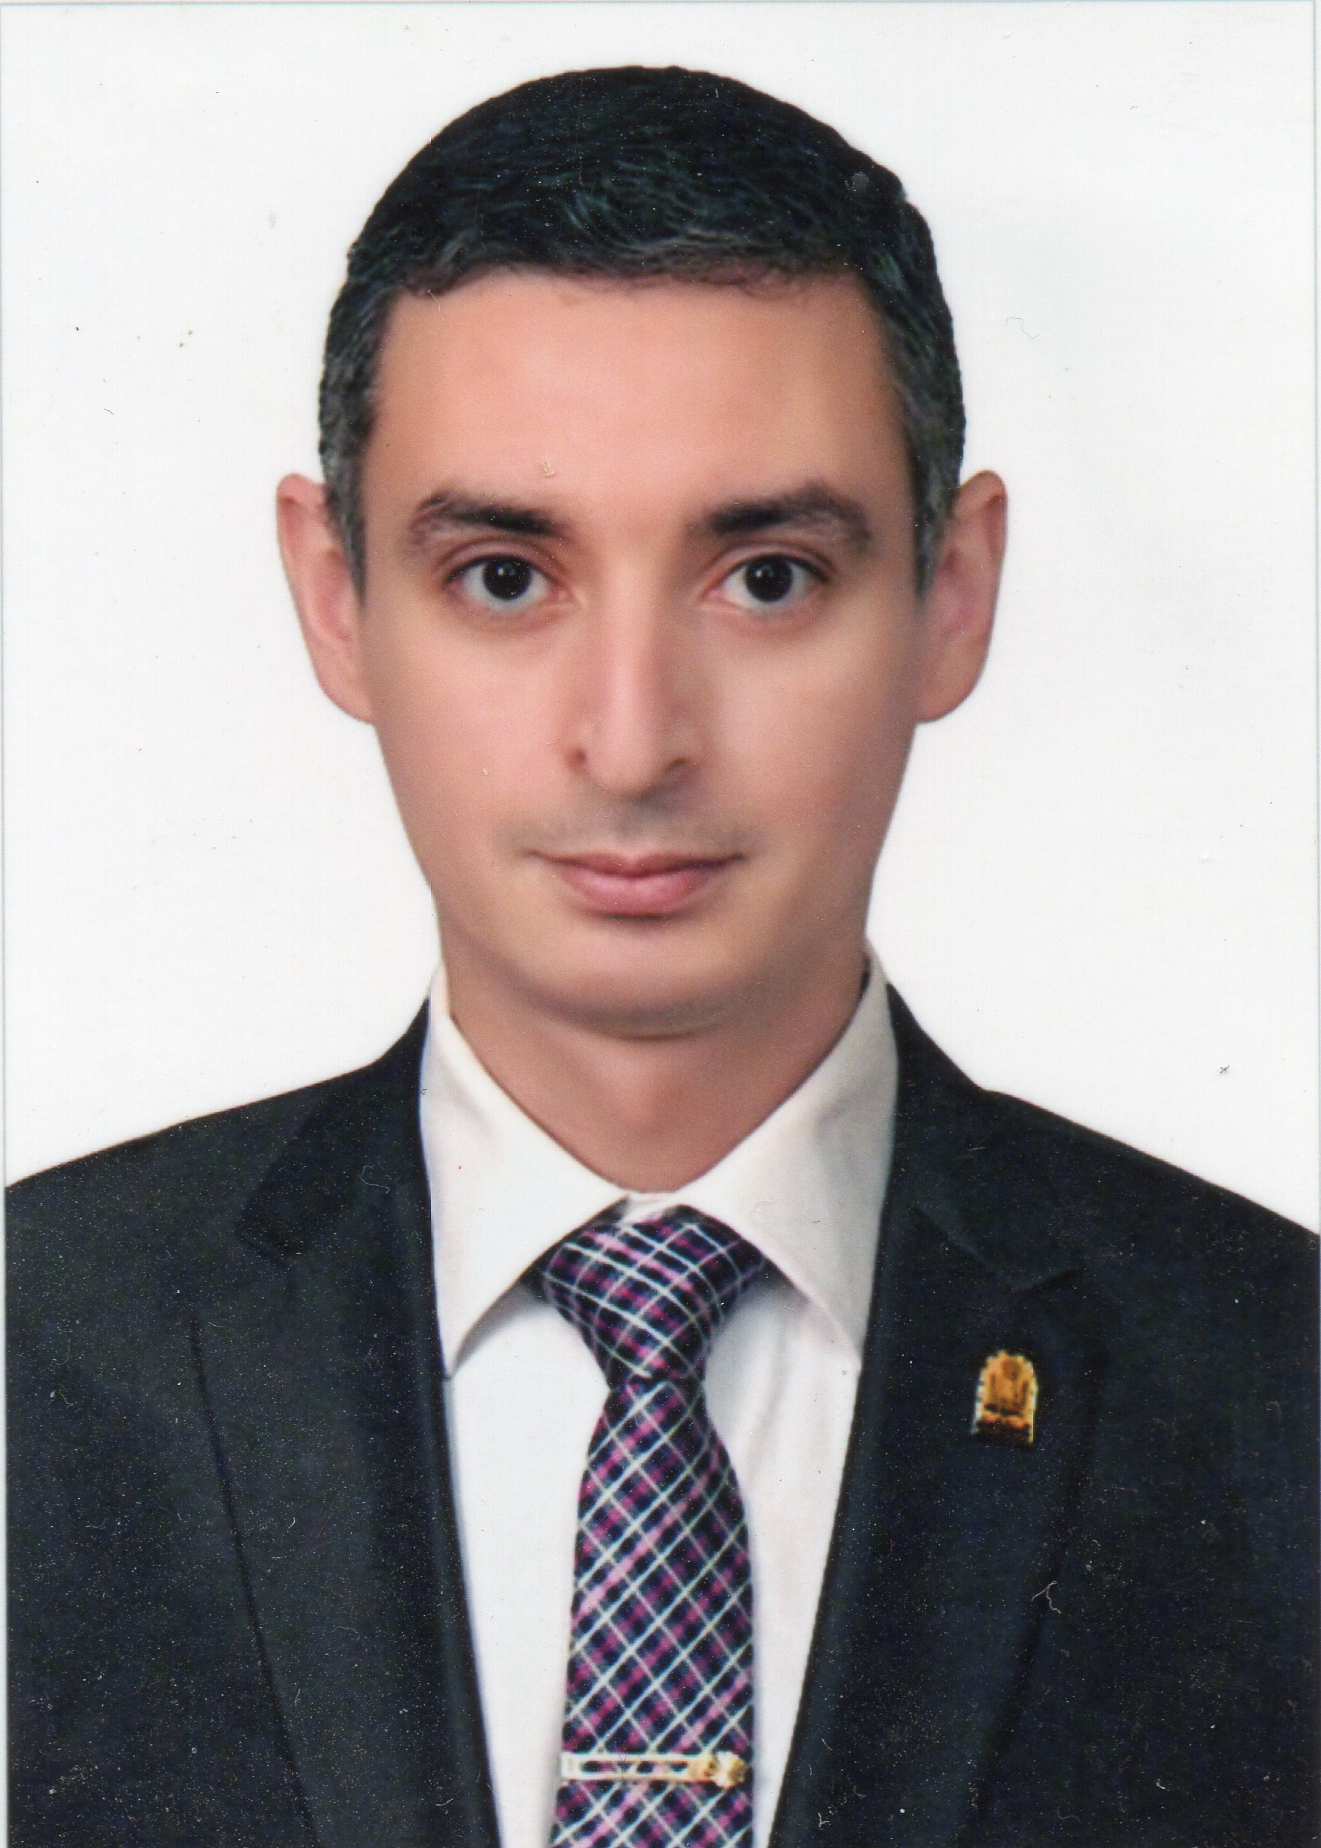Birthdate: June 6th, 1979.

Sex: Male.

Nationality: Egyptian.

Place of Birth: Assiut, Egypt.

Marital Status: married and has 2 of springs

Tel: (+49)9721/7932711

Office: (+49)9771/662259

Fax: (+49)9771/ 65 98 - 9225

Mobile: (+49) 15258641460

E-Mail: aymanfaaa@yahoo.com

Current Adress:

Home: Stresemann Str. 11, 97424, Schweinfurt, Germany.

Work: Salzburger Leite, 1, 97616, Bad Neustadt a. d. Saale, Germany.

Professional Title:

Lecturer of orthopedic surgery and traumatology, Faculty of Medicine, Assiut University, Egypt.

Current occupation:

Resident of orthopedic surgery in the clinic for shoulder surgery in Bad Neustadt, Germany.

Subspecialty:

Orthopedic Trauma Surgery

Arthroscopic surgery and sports Knee injuries.

Since 2011 subspecialized in Shoulder and Elbow Surgery.

Foreign Languages:

German: B2 Level (Common European Framework of Reference for Languages (CEFR)).

English:

TOEFL.ITP Test: Score 553/677 Correspond to B2 level (Common European Framework of Reference for Languages (CEFR)).

All medical studies and exams are done in English.

Educational Background:

June 1996: Ended the Secondary School Study in Egypt. (With Grade 96%)

September 2002: M.B.B.Ch in Surgery and Medicine, Faculty of Medicine, Assiut University, Egypt. (With general grade of Excellent with honor).

April 2007: M.Sc. in Orthopedics surgery and Tarumatology Faculty of Medicine, Assiut University, Egypt. (With general grade of Excellent).

Sept. 2011: Passed the SICOT Diploma Examination in Prague.

Sept. 2013: become a licensed physician in Germany.

Nov. 2013: Technical qualification in the field of Radiation Protection, Munich, Germany.

December 2016: MD in Orthopedic Surgery, Faculty of Medicine, Assiut University, Egypt.

Training and Work Experiences:

3/2003 To 2/2004: Intern, Assiut University Hospital, Assiut, Egypt.

3/2004 up to 6/2007: Resident of Orthopedics surgery and traumatology, Assiut University Hospital, Assiut, Egypt.

7/2007 up 3/2011: Specialist of Orthopedics surgery and traumatology, Assiut University Hospital, Assiut, Egypt.

1/3/2010 up to 30/8/2010 “SICOT Assiut Würzburg Fellowship”: 6 months surgical training in Würzburg Orthopedic University Clinic (König-Ludwig-Haus) In Germany.

12/7/2010 up to 23/7/2010: 2 weeks as guest doctor in Department of shoulder surgery, Rhoem Clinic, Bad neustadt, Germany

1.4.2011 -1.1.2017: Resident of Orthopedics surgery in the Clinic for Shoulder Surgery, Bad Neustadt a. d. Saale, Germany

1.1.2017- Up to date: Specialist of Orthopedics surgery in the Clinic for Shoulder Surgery, Bad Neustadt a. d. Saale, Germany

Academic Work and Experiences:

3/2007 up to 6/2007: Demonstrator of Orthopedics surgery and traumatology, Assiut University Hospital, Assiut, Egypt.

7/2007 up to 12/2016: Assistant Lecturer of Orthopedics surgery and traumatology, Assiut University Hospital, Assiut, Egypt.

6/2007 up to 3.2010: Instructor and Trainer for First Aids in Trauma in the Assiut Medical education development Center. Faculty of medicine Assiut University, Egypt.

6/2007 up to 3.2010: Instructor and Trainer for Basics of Arthroscopic Surgery in the Assiut University Center for Endoscopic surgical Training. Faculty of medicine Assiut University, Egypt.

1.1.2017 up to date: Lecturer of Orthopedics surgery and traumatology, Assiut University Hospital, Assiut, Egypt.

Since 2015: Reviewer in the following Journals:

Journal of Shoulder and Elbow Surgery (JSES)

Journal of Sports Sciences (J SPORT SCI)

Journal of Shoulder and Elbow Surgery open Acess (JSESOA)

Since 4.2016: Instructor for Comperhensive Truma Life support (CTLS) in india and Egypt.

Since 11.2017: Instructor for Advanced Truama Life Support (ATLS) in Germany and Egypt.

Master Thesis:

The Role of Endoscopy in Treatment of Adolescent Idiopathic Scoliosis. (Essay)

Master Thesis:

Single Bundle Versus Anatomic Double Bundle Anterior Cruciate Ligament Reconstruction.

Membership:

SECEC: European Society for Shoulder and Surgery

DVSE: German association for shoulder and elbow surgery

Egyptian Orthopedic Association.

AO Spine Europe.

The Egyptian Group of Arthroscopy and Sports Injuries. (EGASI)

SICOT: The World Orthopaedic Organisation

Assiut Childhood and Development Association. (Non-for-profit organization caring for handicapped children), Assiut, Egypt.

Courses and conferences attended:

June 16-17, 2005: Intensive Course XVI, Instructional Hip Problem Course, Cairo, Egypt.

September 22-23, 2005: Intensive Course XVII, Review Course on Fracture Treatment, Cairo, Egypt.

December 20-22, 2005: Refresher Course on Musclo-skeletal Imaging, Assiut, Egypt.

March 2-3, 2006: 3rd Basic Training Course in Methods of Ilizarov, Cairo, Egypt.

March 13-15, 2006: 1st AO Spine Seminar & Workshop, Cairo, Egypt.

March 18-19, 2006: Minimally Invasive Spine Course, Alexandria, Egypt.

May 4-5, 2006: Basic and Advanced Course of Arthroscopy Knee, Alexandria, Egypt.

May 12, 2006: Management of poliomyelitis, Assiut, Egypt.

May 18-20, 2006: The 2nd International Course and workshop of Skeletal Deformities Correction, Cairo, Egypt.

September 6-8, 2007: The trauma course by British Orthopedic Association and Egyptian Orthopedic Association, Cairo, Egypt.

October 25-26, 2007: Shoulder arthroscopy basic and advanced course, Al Azhar University, Cairo, Egypt.

November 26-29, 2007: 59th Annual international congress of the Egyptian Orthopedic Association, Cairo, Egypt.

6-8 Febrauray 2008: Assiut Knee & Shoulder Arthroscopy Course. Assiut University, Assiut, Egypt. (Organizer).

November 2008: 60th Annual international congress of the Egyptian Orthopedic Association, Cairo, Egypt.

October 2008: Computer in orthopedics course and workshop, Ain-shams University. Egypt.

June 2009: AO Advanced course of internal fixation, Cairo, Egypt.

29 October- 1 november 2009: 6th SICOT/SIROT annual international conference, Pattaya, Thailand

November 2009: East-west shoulder surgeries course, 6th October City, Egypt.

December 2009: Annual International Conference of Egyptian Orthopedic Association, Cairo, Egypt.

9-10 July 2010: AE- Course of Shoulder Surgery, Stuttgart, Germany.
  - Dezember 6-9, 2010: 62th Annual international congress of the Egyptian Orthopedic Association. Kairo, Ägypten.

6-9 September 2011: SICOT 2011 XXV Triennial World Congress Prague, Czech Republic.

17-19. February 2012: basic course for the protection against the hazards of Radiation, Bad Neustadt a.d. Saale, Germany.

1-2 June 2012: basic course for the protection against the hazards of Radiation, Bad Neustadt a.d. Saale, Germany.

20- 22 June 2013: 20. Annual Congress of the German association for Elbow and shoulder Surgery (DVSE). Würzburg, Germany.

19-22 March 2014: orthopedics and Trauma surgery refreshing course, Düsseldorf, Germany.

3-5 April 2014: 21. Annual Congress of the German association for Elbow and shoulder Surgery (DVSE). Wiesbaden, Germany.

26 May 2014: CRP-Simulationtraining. Rhön Clinic, Bad Neustadt (saale), Germany.

17-20 September 2014: 25th SECEC_ESSSE Congress. Istanbul, Turkey.

26-28 November 2015: 2nd Assiut Shoulder Arthroscopy Course (Hand on & Live surgery + Cadaveric wetlab), Assiut University Hospital, Assiut, Egypt.

7-10 December 2015: Annual International Conference of Egyptian Orthopedic Association, Cairo, Egypt.

25-27 March 2016: Instructors and providers course of the Comperhensive Trauma Life Support (CTLS). Ganga Hospitals, COimbator, India.

30 March 2016: The First Annual Specialities Clinical Meeting, Department of Orthopedics-Assiut with the Egyptian Orthopedic Association (EOA).

5th - 7th April 2016: First Ankle Arthroscopy Course - Assiut Arthroscopy & Sports injuries Unit, Assiut University Hospital, Assiut, Egypt.

10 May 2016: AO Trauma-Roadmap to Research Symposium. Cairo Egypt.

9-11 June 2016: 23. Annual Congress of the German association for Elbow and shoulder Surgery (DVSE). Bremen, Germany.

11-13 October 2016: 2nd Assiut Hip Arthroscopy & Arthroplasty Cadaveric Course. Assiut Arthroscopy & Sports injuries Unit, Assiut University Hospital, Assiut, Egypt.

23-25 November 2016: Advanced Trauma Life Support (ATLS) Providers Course. Assiut University Resuscitation Center, Assiut, Egypt.

13 -16 September 2017: 27th SECEC_ESSSE Congress. Berlin, Germany

3-4 November 2017: Instructor course in Advanced Trauma Life Support (ATLS), Cologne, Germany

Additional Experience, academic training:

October, 2003: Obtained the International Computer Driving License (ICDL).

June 2-4, 2007: The training program “research methodology” held by “The Faculty and Leadership Development project (FLDP)”, Assiut University, Egypt.

June 9-11, 2007: The training program “The Effective Presentation” held by “The Faculty and Leadership Development project (FLDP)”, Assiut University, Egypt.

June 19-21, 2007: The training program “teaching with technology” held by “The Faculty and Leadership Development Project (FLDP)”, Assiut University, Egypt.

June 23-25, 2007: The training program “preparing writing scientific research and international Publishing” held by “The Faculty and Leadership Development Project (FLDP)”, Assiut University, Egypt.

Feb. 2008: Designed the new symbol of the arthroscopy Unit in orthopedic department, Assiut University hospital.

8-9 May 2016: Training Program of Quality Standards in Teaching. by “The Faculty and Leadership Development Center (FLDC)”, Assiut University, Egypt.

14 May 2016: Workshop in Methods of Teaching and Assessment. Faculty of medicine, Assiut University.

15-16 May 2016: Training Program of Strategic Planning. by “The Faculty and Leadership Development Center (FLDC)”, Assiut University, Egypt.

22-23 May 2016: Training Program of E-Learning. by “The Faculty and Leadership Development Center (FLDC)”, Assiut University, Egypt.

29-30 May 2016: Training Program of Analytic and creative thinking. by “The Faculty and Leadership Development Center (FLDC)”, Assiut University, Egypt.

1-2 June 2016: Training Program of Statistical analysis in scientific research. by “The Faculty and Leadership Development Center (FLDC)”, Assiut University, Egypt.

1-2 June 2016: Training Program of How to activate the E-Course. by “The Faculty and Leadership Development Center (FLDC)”, Assiut University, Egypt.

20-26 September 2016: Workshop in International Publication. Faculty of medicine, Assiut University.

General Interests and Skills

Computer work and Information Technology

Sporting: Swimming.

Primary language: Arabic.

Lectures, Posters and Congress Presentations:

Complications of arthroscopy. Knee arthroscopy Basic and advanced course, Assiut University center for teaching endoscopic surgery, March 2009

PCL Injuries. Knee arthroscopy Basic and advanced course, Assiut University center for teaching endoscopic surgery, March 2009

Arthroscopic synovectomy. Knee arthroscopy Basic and advanced course, Assiut University center for teaching endoscopic surgery, March 2009.

The slope of ACL bundles for accurate transtibial anatomic reconstruction: a cadaveric study: AbdelKawi AF., Kady HA., Abd El-hamid MM., Said HG, El-Assal MA. Poster in SICOT annual international conference Pattaya, Thailand, 29 oct-1 Nov 2009.

Hip Arthroscopy in Egypt Early Results. Said HG, AbdelKawi AF, El-Assal MA. Annual International Congress of Egyptian Orthopedic Association. Cairo, Egypt. Dec. 2009.

Reverse shoulder arthroplasty for neglected anterior dislocation with advanced glenoid bone loss. Werner B., Boehm D., Abdelkawi Abdelgalil A., Gohlke F. 24. SECEC-ESSSE Congress. Dubrovnik, Croatia. Sept., 2012.

Propionibacterium acnes in der Schulterchirugie: Infektion, Kontamination oder chronische Persistenz im Gewebe unterhalb der Hautschicht? Hudek R., Abdelkawi A., Loos F., Gohlke F. 20. Jahreskongress der DVSE, Würzburg, Germany. June, 2013.

Die inverse Schulterprothese in der Versorgung veralteter vorderer Schulterluxationen mit Glenoiddefekten. Werner B., Böhm D., Abdelkawi Abdelgalil A.F., Gohlke F. 20. Jahreskongress der DVSE, Würzburg, Germany. June, 2013.

Propionibacterium acnes in shoulder surgery: True infection, contamination or resident of the deep tissue beyond the skin? Hudek R., Sommer F., Abdelkawi A., Loos F., Meier R, Gohlke F. SECEC-ESSSE closed meeting, Madrid, September 2013

Results of one stage reconstruction of massive glenoid bony defects with resected humreal head during the primary implantation of reverse shoulder Prosthesis. Abdelkawi AF., Hudek R., Werner B., Gohlke F. 21. Jahreskongress der DVSE. Wiesbaden, Germany April, 2014.

Propionibacterium acnes in der Schulterchirurgie: Gibt es einen Zusammenhang mit subjektiven Hautbeschwerden? Hudek R., Sommer F., Abdelkawi A., Loos F., Gohlke F. 21. Jahreskongress der DVSE. Wiesbaden, Germany April, 2014.

Results of one stage reconstruction of massive glenoid bony defects with resected humreal head during the primary implantation of reverse shoulder Prosthesis. Abdelkawi AF., Hudek R., Werner B., Gohlke F. 25. Annual Meeting of the SECEC. Istanbul, Turkey, September, 2014.

Shoulder MRI. 2nd Assiut Shoulder Arthroscopy Course (Hand on & Live surgery + Cadaveric wetlab), Assiut University Hospital, Assiut, Egypt. 26-28 November 2015.

Results of one stage reconstruction of massive glenoid bony defects with resected humreal head during the primary implantation of reverse shoulder Prosthesis. Abdelkawi AF., Hudek R., Werner B., Gohlke F. Annual International Congress of Egyptian Orthopedic Association. Cairo, Egypt. Dec. 2015.

Arthroscopic synovectomy. Fifth Knee & ACL Arthroscopy Course - Assiut Arthroscopy & Sports injuries Unit, Assiut University Hospital, Assiut University. 7- 10 April 2016.

When to do osteotomy for unicompartment arthritis, The typical indication and the proper selection. Knee Cartilage Preservation Course. National training institute. Cairo 6th - 7th of October 2016

Tunnel Positioning in ACL Reconstruction: 6th Assiut ACL (A to Z) Master Course. Assiut Arthroscopy & Sports injuries Unit, Assiut University Hospital, Assiut University. 26-27 April 2017.

A Shortcut to Arthroscopic Suprascapular Nerve Decompression at the Suprascapular Notch. HG Said, AF AbdelKawi, TN Fetih, AW Kandil 27 SECEC-ESSSE congress berlin - germany 13-16 sept 2017

Publicashions

El-Kady HA, Abdel-Hamid MM, Said HG, AbdelKawi AF, El-Assal MA. The slope of anterior cruciate ligament bundles for accurate transtibial anatomic reconstruction: a cadaveric study. The Egyptian Orthopaedic Journal. 2014 Oct 1;49(4):304.

Werner B., Boehm D., Abdelkawi A., Gohlke F. Glenoid bone grafting in reverse shoulder arthroplasty for long-standing anterior shoulder dislocation. Accepted for publication in the Journal of Shoulder and Elbow Surgery, March 2014.

Hudek, R., Sommer F., Kerwat M., Abdelkawi AF., Loos, F., Gohlke F. Propionibacterium acnes in shoulder surgery: true infection, contamination, or commensal of the deep tissue? Journal of Shoulder and Elbow Surgery, 2014. 23(12): p. 1763-1771.

Hudek R, Sommer F, Abdelkawi AF, Kerwat M, Müller HH, Gohlke F. Propionibacterium acnes in shoulder surgery: is loss of hair protective for infection?. Journal of shoulder and elbow surgery. 2016 Jun 30;25(6):973-80.

Werner BS, Abdelkawi AF, Boehm D, Hudek R, Plumhoff P, Burkhart KJ, Gohlke F. Long-term analysis of revision reverse shoulder arthroplasty using cemented long stems. Journal of shoulder and elbow surgery. 2017 Feb 28;26(2):273-8.

Hudek R, Werner B, Abdelkawi AF, Schmitt R, Gohlke F. Radiolucency in stemless shoulder arthroplasty is associated with an imaging phenomenon. Journal of Orthopaedic Research. 2017.

Bayoumy MA, Said HG, Abdelkawi AF, Fetih TN. Treatment of Irreducible Traumatic Anterior Shoulder Dislocation Caused by Subscapularis Tendon Interposition. Arthroscopy Techniques. 2017.

Said HG, AbdelKawi AF, Fetih TN, Kandil AW. A Shortcut to Arthroscopic Suprascapular Nerve Decompression at the Suprascapular Notch: Arthroscopic Landmarks and Surgical Technique. Arthroscopy Techniques. 2017 Sep 25.

Werner BS, Stehle J, Abdelkawi A, Plumhoff P, Hudek R, Gohlke F. Progressive glenoid bone loss caused by erosion in humeral head resurfacing. Der Orthopäde. 2017 Oct 23:1-6.

Hudek R, Werner B, Abdelkawi AF, Gohlke F. Pyrocarbon interposition shoulder arthroplasty in advanced collapse of the humeral head. Der Orthopäde. 2017 Oct 27:1-9.

References:

Prof. Frank Gohlke:
Head of the Clinic for Shoulder Germany, Bad Neustadt a. d. Saale, Germany. Former President of the German association for shoulder and elbow surgery (DVSE). Former President for European association for Shoulder and Elbow Surgery (SECEC). Salzburger Leite 1, 97616, Bad Neustadt a.d. Saale, Germany. Tel. (+49) 9771/66-2251. Fax. (+49) 9771 65989225. E-mail: frank.gohlke@uni-wuerzburg.de

PD. OA. Klaus Burkhart:
Specialist for orthopedic Surgery and Traumatology, ARCUS Clinic, Pforzheim, Germany. Rastatter Str. 17-19, 75179 Pforzheim, Germany. Tel. (+49)7231/60556-0
Fax. (+49)7231/60556–3089.
E-mail: burkhart@sportklinik.de

Prof. Hatem G.Z. Said
Professor of Orthopedic Surgery and Traumatology, member of arthroscopy and sports injuries unit, orthopedic department. Assiut School of Medicine, Assiut University, Assiut, Egypt. Young Surgeons Committee Chairman of the SICOT. International Affiliate Member of the American Academy of Orthopaedic Surgeons. Assiut 71516, P.O. Box 110, Egypt. Tel. (+2088)(2413343), (+20121762266). Fax. (+2088)(2332278). E-mail: hatemgalal@yahoo.com

Prof. Maher A. El-Assal
Professor of Orthopedic Surgery and Traumatology, Dean of Assiut School of Medicine, Assiut University, Assiut, Egypt. Head of arthroscopy and sports injuries unit, orthopedic department. Head of the Egyptian Group of Arthroscopy and Sports Injuries (EGASI). Assiut 71516, P.O. Box 110, Egypt. Tel. (+20)88/2354303, (+20)88/2411916, (+20)88/2413665, (+20)122412413. Fax. (+20)88/2354303.
E-mail: elassal88@hotmail.com

